^{Hi There.}
Thanks for downloading this free resource.

^{We hope you find it useful.}
Feel free to customize it your way. And, remember, there’s more where it came from. Head straight to www.maddabookmedia.com to explore our author toolkit library packed with free templates.
Need a guide on how to use it? Click to Learn More

How to Use This Template
Use the Primer Book Outline Template tool to clarify your book-worthy idea. It has been designed to aid nonfiction authors, especially first-time authors who are busy professionals. There are two main sections. Section 1 covers pre-writing essentials. While Section 2 covers first draft essentials.
- Section 1:Helps you get clear on the essence of your nonfiction book such as titles, audience, theme, and executive summary or elevator pitch.
- Section 2: Helps you brainstorm your book’s contents and outline your table of contents.
The tables also contain prompts [in square brackets] to help you jump-start your response.
Feel free to customize, expand, and add sections as you, please.

Pre-writing

1. Title:
Reflect the essence of your book in as few words as possible.

Working Title | [Primer Dream Launcher]
Working Subtitle | [Unlock your story to the world. Build a legacy.]
Authored By | [Madda Book Media]

2. Audience:
Who will interact with and benefit from your book the most?

Reader Tribe | [Stay-at-home single moms in Southern Nigeria]
Demographics | Age, location, religion, profession, position, industry, personality, motivations, goals, and frustrations. List all that comes to mind.
Persona
Problem | [Persona] is suffering from…
Effect | This problem is affecting [persona] in ways such as…
Desired Outcome | [Persona] desires a solution that…
Value | How will [persona] benefit from implementing the idea in your book?  - Value One  - Value Two  - Value Three

3. Idea:
Discuss your core message/logic; how it works; and how it will solve for [persona].

Premise | My book is about… It was prompted by… And it’s critical because…
Promise | [Persona] will get…out if they read and apply my book.
Pitch | My book is for Xs who want Y so they can achieve Z.

4. Celebration:
You’re now an author, how will you celebrate your new status? And at what point?

Main Milestone
Celebration

5. Compass:
An executive summary prompt to capture your big picture. See if it's worth committing to.

I am writing a [genre] book titled [WT: WST] for [Reader Tribe] who want [Desired Value] so they can achieve [Lasting Outcome]. Thus, by impacting my readers I will reach [ROI]. I now pledge to finish this transformational project that I have started. When I do, I will celebrate my authorship by [Celebration].

Shitty First Draft

1. Brainstorming
Brain-dump the ideas and stories you have that could go into your book. Focus on what information your reader needs to solve their problem and achieve transformation.

1. Opening Big Idea (Ch. 1):

The goal of your opening beat is to immediately command the audience’s attention. Your introductory discussion should represent the struggle and tone of your story, giving a snapshot of your reader’s main problem before your book’s dive starts in earnest.

2. Chapters
Now, break down your information into your table of contents.

Chapter | Working Title | Keypoint | Key Takeaway | Written?
One |  |  |  | Yes
Two |  |  |  | Yes
Three |  |  |  | No
Four |  |  |  | No
Five |  |  |  | No
Six |  |  |  | No

Did you find this template helpful?

Join Book Lab author community today.
Access support, coaching, and everything you need to help you start and finish your book.

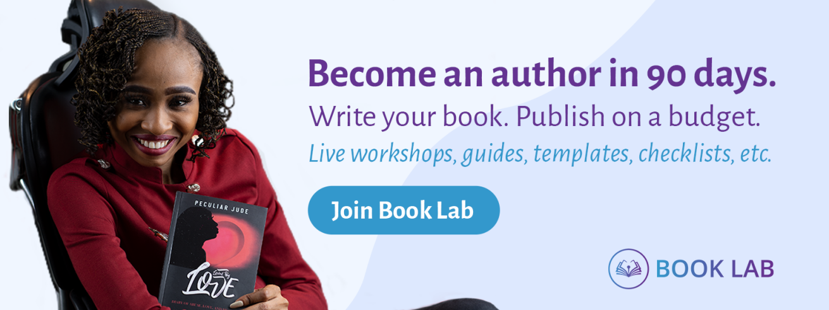
Join Book Lab Today

